Insrtructions for preparing the paper for

the 5th Jc-IFToMM INTERNATIONAL symposium

first Author

Department, University Name, Country, email@abc.def.jp

Second Author

Section, Company Name, Country, email@ghij.kl.tw

**ABSTRACT**

These instructions explain how to prepare your paper in the proceedings of 5th Jc-IFToMM International Symposium in conjunction with the 28th Jc-IFToMM Symposium on Theory of Machines and Mechanisms to be held on 16th July, 2022 at Katsura Campus, Kyoto University. They include guidance on layout, illustrations, text style and references. It is highly advised to use this template to prepare your paper in Microsoft Word. The brief abstract with about 100 words in English should be written here. About 5 keywords which can represent main issues of the paper should be written below. All papers must be written in English or Japanese. SI-units should be used. The paper should not exceed **eight pages**. Manuscripts must be submitted through the designated website (if necessary, manuscripts sent by attachments of emails will be accepted: symposium@jc-iftomm.org) before the date specified on the website, in PDF file together with the Form of License to Publish.

**KEY WORDS:** Mechanism, Machine Elements, Robotics, Medical Devices

# INTRODUCTION

Authors are advised to use this template following the instruction written in this template.

# NUMBER OF PAGES

Each paper should be prepared from **two(2) to eight(8) pages**.

# GUIDELINES

**3.1 Use of our template**

You can delete our sample text and replace it with the text of your own contribution to the proceedings. However we recommend that you keep an initial version of this file for reference.

Please set your page size as standard A4. The top and bottom margins should be set at 50 mm each; right and left margins at 35 mm each. The header and footer should be set at 30 mm each.

**3.1.1 Font size**

The text should be set in 10 pt Times New Roman with single-line spacing. Type the title of the paper in 12 pt Times New Roman boldface, all upper case. Chapters should be in 10 pt Times New Roman boldface, upper case, centered. Sections in 10 pt Times New Roman boldface, lower case. If there is a sub-section, then it should be 10 pt Times New Roman italics, lower case. Font sizes are summarized in Table 1.

Authors’ names are set in 10 pt Times New Roman, upper case. Affiliations are in 10 pt Times New Roman italics. Figure and table captions also should be in 10 pt, lower case.

**3.1.2 Line spacing**

Table 1 Fonts used in the proceedings

|  |  |  |
| --- | --- | --- |
| Text type | Fonts | Sizes |
| Title | Times New Roman, Boldface, All Uppercase, Centered | 12 pt. |
| Name and Affiliation of Authors | Times New Roman, Uppercase, Centered | 10 pt. |
| Abstract | Times New Roman | 10 pt. |
| Main Text | Times New Roman | 10 pt. |
| Title of Chapters | Times New Roman, Boldface,  All Uppercase, Centered | 10 pt. |
| Title of Sections, Sub-sections | Times New Roman, Boldface, Uppercase | 10 pt. |
| Title of Tables | Times New Roman, Centered | 10 pt. |
| Title of Figures | Times New Roman, Centered | 10 pt. |

Each new chapter should be preceded by a single-line spacing.

**3.2 Equations**

Equations should be aligned to left margin and numbered consecutively, as in Eq. (1). Equation numbers should be aligned to right margin. An alternative method is given in Eq. (2) for long sets of equations where only one referencing equation number is required.

**3.3 Citations**

The papers in the reference list must be cited in the text. In the text, the citation should appear in square brackets “[ ]”, as in, for example James *et al.* [1].

**3.4 Tables**

The tables are designed to have a uniform style throughout the paper. It does not matter how you choose to place the inner lines of the table, but we would prefer the border lines to be of the style shown in Table 1. For the inner lines of the table, it looks better if they are kept to a minimum. The caption heading for a table should be placed at the top of the table. Tables should preferably be located at the top or bottom of the page where they are first cited.

**3.5 Figures**

It is best to embed the figures in the text where they are first cited and to locate them at the top or bottom of the page, e.g. see Fig. 1. Please ensure that all labels in the figures are legible regardless of whether they are drawn electronically or manually. The caption heading for a figure should be placed below the figure.

Authors are advised to prepare their figures in black and white. Please prepare the figures in high resolution (300 dpi) for half-tone illustrations or images. Half-tone pictures must be sharp enough for reproduction, otherwise they will be rejected.

**3.6 Acknowledgments**

If you wish to acknowledge funding bodies etc., the acknowledgments may be placed in a separate section at the end of the text.

 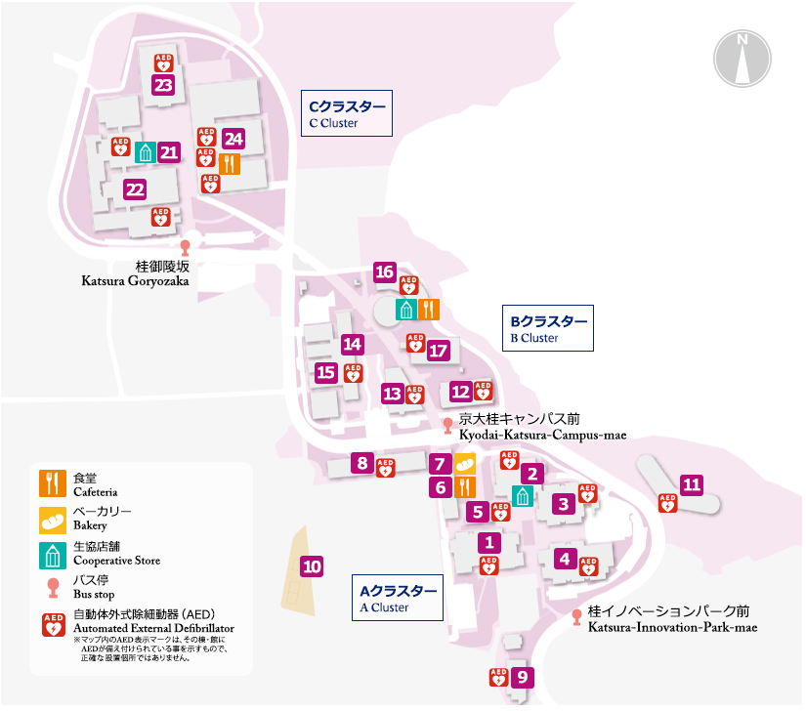

Fig.1 Example of figure Jc-IFToMM logo Fig.2 Place of Japan-IFToMM symposium

# SUBMISSION OF MANUSCRIPT

Please upload the PDF (all fonts should be embedded) file of your manuscript and the copyright transfer form to the designated website or send the files to symposium@jc-iftomm.org as attachment files of an email before **May 6, 2022**.

# PLACE OF SYMPOSIUM

The 5th Jc-IFToMM International Symposium in conjunction with the 28th Jc-IFToMM Symposium on Theory of Machines and Mechanisms will be held at Katsura Campus, Kyoto University.. We look forward to seeing you at historical place Kyoto!

Please feel free to contact to the email address if you have any questions.

# REFERENCES

1. Author A. B.: Title of Book, ABS Press (2000), pp. 23-35.
2. Author, J. Q., Title of Paper, *Name of Journal*, Vol. 10(1993), No. 6, pp. l-20.